International Center for Zettawatt-Exawatt Science and Technology

IZEST

Gérard Mourou and Toshiki Tajima

The first International Laser Center designed to explore Fundamental Physics at the highest-intensity frontiers.

Solving the Ultra-High Peak Power and High Average Power quandary paramount to its Application Agenda

Content

1. Introduction 2

2. IZEST 2

3. Technology issues 3

4. Scientific Rationale for IZEST: Laser Based High Energy Fundamental Physics 4

5. Implementation of IZEST 6

6. IZEST Structure 7

7. References 10

Palaiseau, November 2011

# Introduction

The scientific community working on the Extreme Light Infrastructure (ELI) has built over the past 5 years a compelling scientific case [[1]] based on the original vision toward Exa- and Zettawatt lasers and their science scope [[2]], showing that the ultra intense field could be of the upmost relevance to fundamental physics and its applications.

More recently the unification of the high intensity and high energy density demonstrated through the Intensity-Pulse Duration conjecture by G. Mourou and T. Tajima [[3]] has unified the ultra high peak power in the exawatt-zettawatt and ultra short pulses in the zeptosecond regimes. One of the remarkable conclusions of their work has been that the shortest pulses could be ultimately produced by the largest scale laser infrastructures such as NIF, the Laser Megajoule and LIL. Their work gives a new wind to large-scale laser infrastructure missions and reaffirms their potential relevance to fundamental physics. ELI’s scientific case has also stimulated a number of countries such as the USA, Japan, China, and Russia to consider building ELI-type infrastructures. It has also highlighted the benefit to go to even higher intensities, advocating the larger scientific and technological bounty that would unfold.

One of the major roadblocks preventing widespread applications of high intensity laser is its low average power, low repetition rate and dismally low efficiency. A novel laser architecture has been proposed recently by G. Mourou based on fiber-laser [[4], [5]] that has the potential to solve this problem. The proposal called ICAN for International Coherent Amplification Network, that involves 18 laboratories throughout the world has been accepted for funding by the European Commission in 2011 to study a possibility to address this problem.

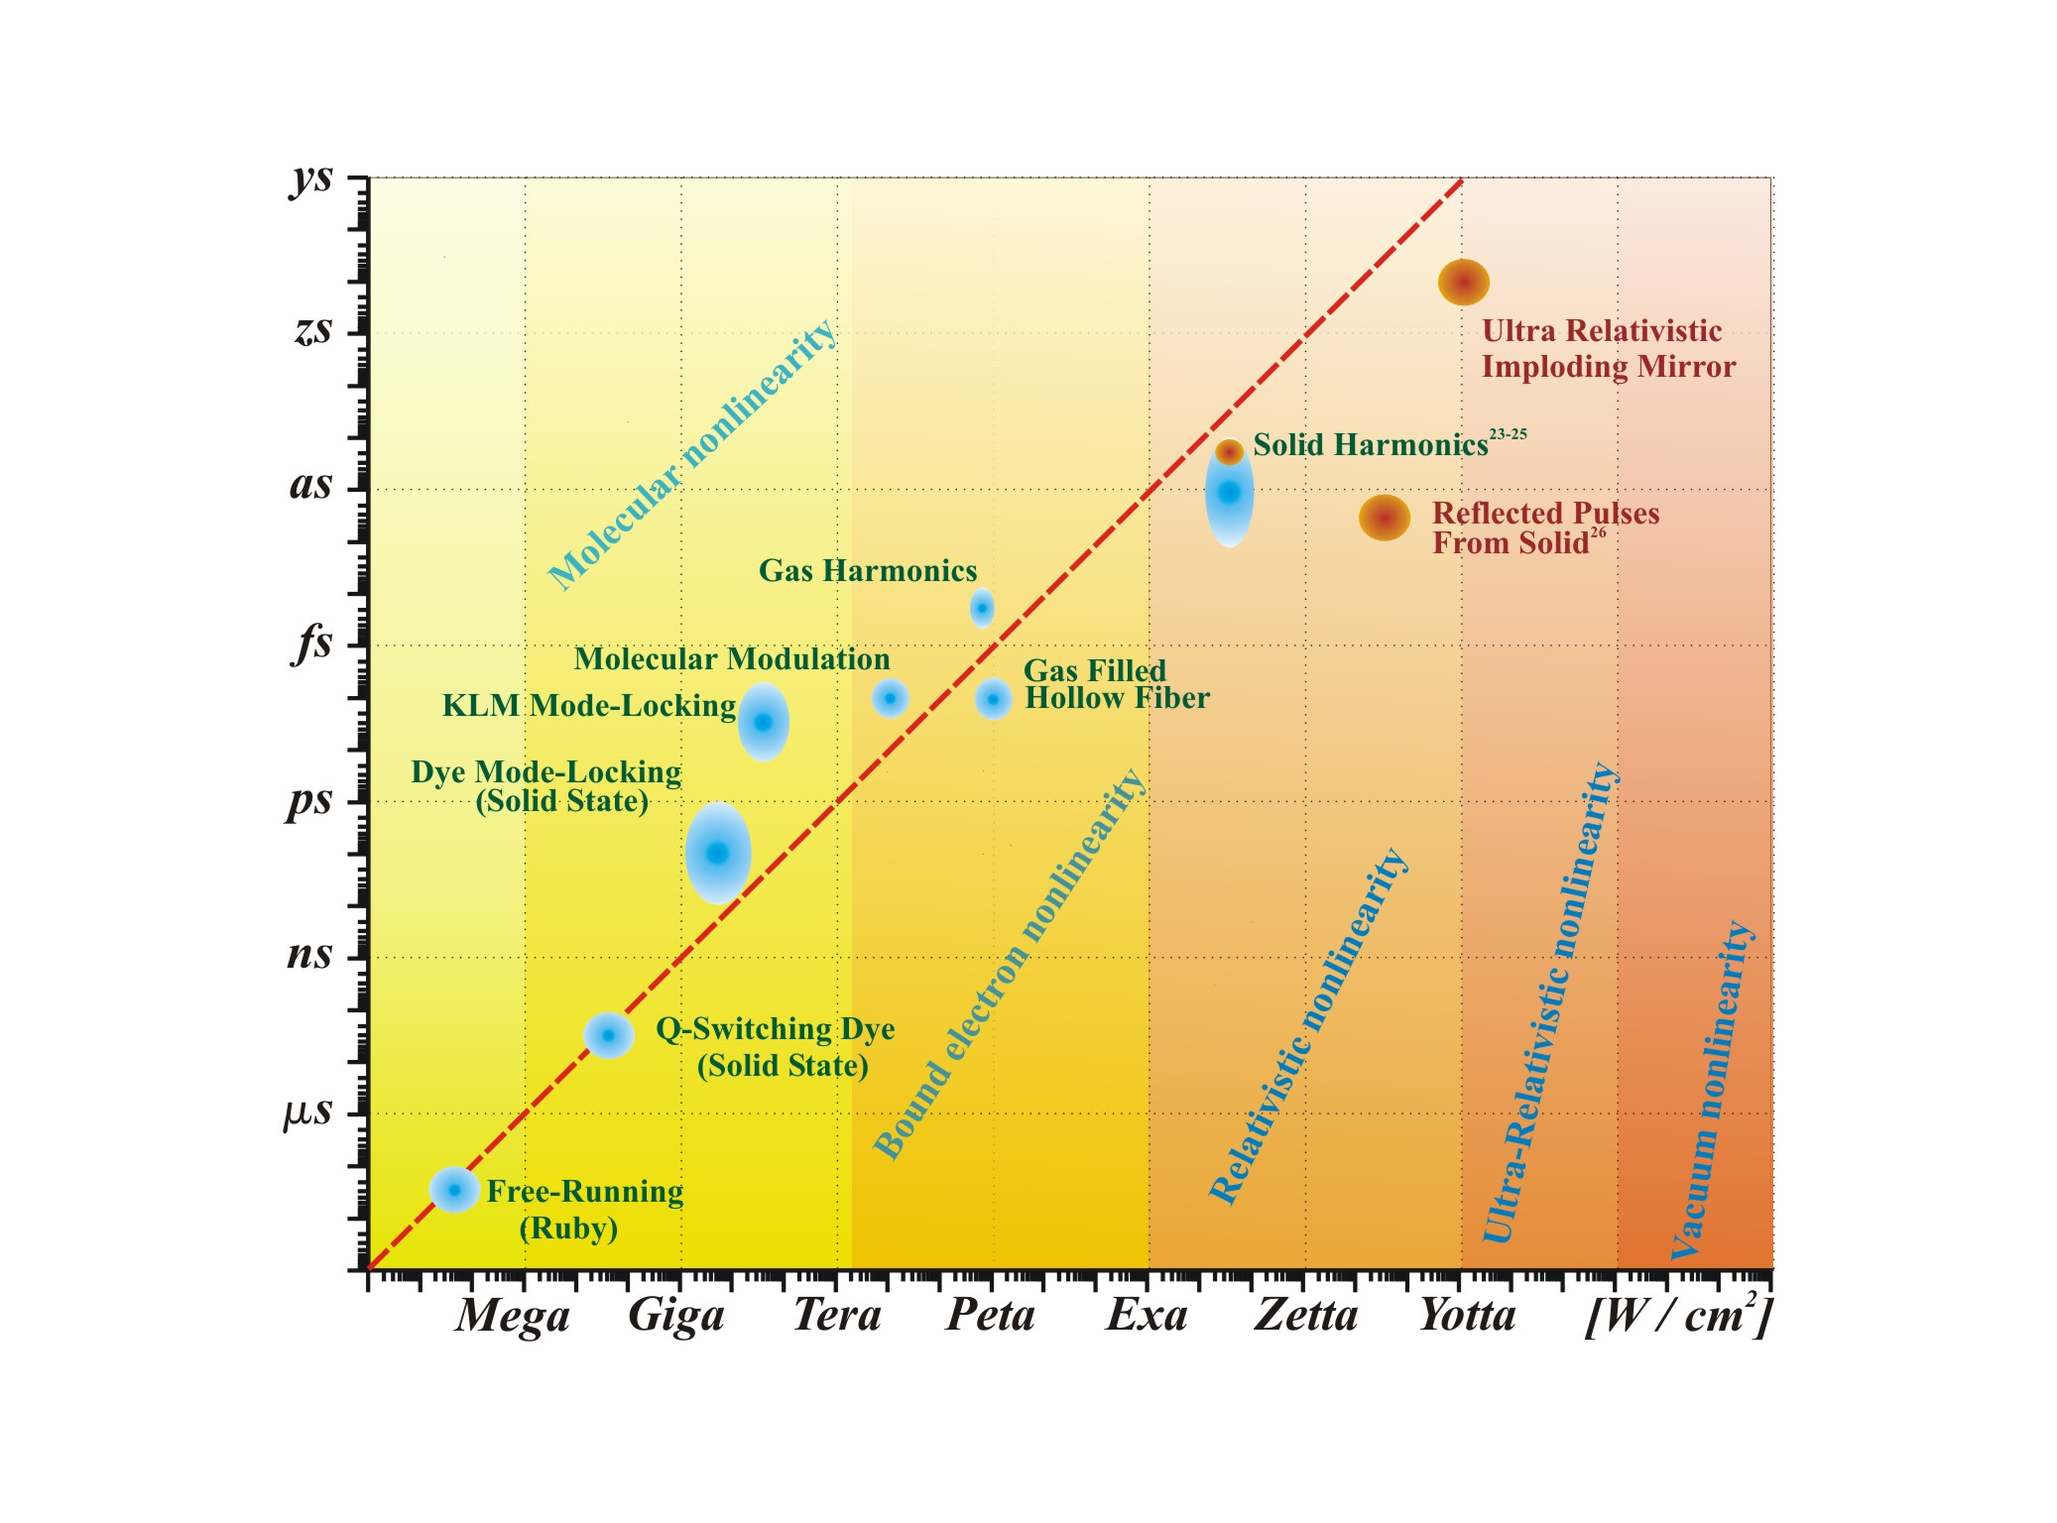

Figure  : An inverse linear dependence exists over 18 orders of magnitude between the pulse duration of coherent light emission and the laser intensity. These entries encompass different underlying physical regimes that exhibit molecular, bound atomic electron, relativistic plasma, ultrarelativistic, and vacuum nonlinearities. Blue patches represent experimental data; red patches denote simulation or theory.

# IZEST

Built on these scientific and technological premises, we propose the creation of a novel research laboratory; the International Center for Zetta- and Exawatt Science and Technology (IZEST) with the mission to study the possibility to produce intensities even higher than the ones predicted for ELI (0.2 Exawatt). In the time domain, extremely short pulses with duration in atto-zeptosecond associated with the large fields will be produced to reach this intensities. IZEST will be composed of the world’s top scientists in laser, plasma physics, nuclear physics, high energy physics, general relativity, and the like. Coordinated through IZEST, their objectives will be to form a team of these scientists who can engage their scientific vision and labor of love toward the world highest intensity lasers. Their objective will also be to vet the scientific potential of exawatt laser and provide the scientific community and funding agencies solid scientific and engineering directions and recommendations.

ELI is built out of a conventional technology based on CPA and OPCPA. Due to the large grating size and cost it will be difficult to go beyond the 200 PW level. However, IZEST will make possible to explore at low repetition rates new technologies and architectures that can be further implemented on ELI or the new infrastructures like XCELS planned in Russia. We will peer at architectures capable to produce 10-1000 kJ pulses in 10 fs resulting in peak powers from the exawatt to a fraction of zettawatt with intensities in the realm of Schwinger/Sauter intensity (1029 W/cm²).

The size of the Exawatt projects is ambitious and will require the contribution of the entire scientific community. In this way IZEST stands naturally to become the first Exawatt International Center.



Figure  : Intensity evolution since the first laser demonstration. With the different regimes of relativistic, ultra relativistic, and nonlinear QED, we show in red the regime addressed by IZEST.

# Technology issues

Reaching ultrahigh peak power requires high average power and high efficiency. Unfortunately, current laser systems are notorious for their poor efficiency. This is especially true for high peak-power laser systems exhibiting wall-plug efficiency in the range of 1% at best. For many applications, like particle acceleration and X- and gamma-ray generation requesting average power in the range of kW to 10 MW, this situation is economically untenable. It seriously impairs the spread of important scientific and societal laser applications in research, material science, environment, medicine, and energy.

To solve this problem, the previously mentioned project, studying a novel laser concept known as CAN for Coherent Amplification Network would guarantee simultaneously high peak power and high average powers while exhibiting high efficiency, >30%. The approach of CAN is based on fiber amplification. The adopted strategy for IZEST will rest on the pulse compression of already-built large scale lasers like the LIL, the Megajoule or NIF that can act as large energy reservoirs. These systems represent a large capital investment and have shown their reliability. Therefore, IZEST laser scientists, plasma physicists will focus their efforts on the best way to compress efficiently the laser pulse to its Fourier-Transformed limit with excellent spatial quality. In parallel, theoretical studies by scientists from France, USA, Russia, Germany, Italy, Sweden, Japan, China, Taiwan and elsewhere will study its applications in science and technology as well as practice an aggressive and efficient technology transfer to the industry. Consequently, IZEST will be providing the right environment to study, form and guide an international consortium aiming at solving the high average power and poor laser efficiency for ultrahigh intensity applications.

A new amplification method, weaving the three basic compression techniques, Chirped Pulse Amplification (CPA), Optical Parametric Chirped Pulse Amplification (OPCPA) and Plasma Compression by Backward Raman Amplification (BRA) in plasma will be explored. It is called C3 for Cascaded Conversion Compression. It has the capability to compress with good efficiency kilojoule to megajoule, nanosecond laser pulses into femtosecond pulses, to produce exawatt-and-beyond peak power. In the future, C3 could be used at large-scale facilities such as the National Ignition Facility (NIF) or the Laser Megajoule (LMJ) and open the way to zettawatt level pulses. The beam will be focused to a wavelength spot size with a f#1. The very small beam size, i.e. few centimeters, along with the low laser repetition rate laser system will make possible the use of inexpensive, precision, disposable optics. The resulting intensity will approach the Schwinger value, thus opening up new possibilities in fundamental physics.



Figure  : Diagram showing the compression technique C3 resulting from the cascaded actions of the three basic techniques, CPA, OPCPA and PC. The CPA technique compresses 5ns, 30kJ into a ~20ps pulse. This pulse is used after frequency doubling, to pump an OPCPA. A strong idler wave is produced at 1250nm. The latter seeds, the plasma compression cell where by interfering with the 20ps pump pulse at 1050nm converts and transfers the pump into the seed pulse at 1250 nm. To preserve the pulse shortness, a prism in the OPCPA is used to produce the necessary angular chirp.

# Scientific Rationale for IZEST: Laser Based High Energy Fundamental Physics

Fundamental High Energy Physics has been mainly driven by the high energy colliding charged particle beam paradigm. Today the possibility to amplify laser to extreme energy and peak power offers, in addition to possibly more compact and cheaper ways to help HEP, a suit of complementary new alternatives underpinned by single shot, large field laser pulse, that together we could call Laser-Based High Field Fundamental Physics. The main mission of the International center on Zetta-Exawatt Science and Technology (IZEST) is to muster the scientific community behind this new concept. As an example, we project to use the laser field to probe the nonlinearity of vacuum due to nonlineairities and light-mass weak coupling fields such as Heisenberg-Euler QED, and to search for dark matter and dark energy. We envision that there is a wealth of fundamental physics issues worth pursuing without large luminosity of a collider. Seeking the non-collider paradigm, or a collider without large luminosity, substantially shortens our time-line; we further accelerate the latter by adopting the existing large energy laser LIL. The accelerated research on the non-collider paradigm in TeV and beyond could, however stimulate innovation in collider thinking such as lower luminosity paths, novel radiation cooling, and gamma-gamma colliders. The advancement of intense short-pulsed laser energy by 2-3 orders of magnitude empowers us a tremendous potential of unprecedented discoveries. These include: TeV physics, physics beyond TeV, new light-mass weak-coupling field discovery potential, nonlinear QED and QCD fields, radiation physics in the vicinity of the Schwinger field, and zeptosecond dynamical spectroscopy of vacuum. In addition, we want to take advantage of the ultrashort pulses produced in the femto, atto, and zeptosecond timescale to perform a new type of particle/radiation precision metrology. Finally, the TeV particles that can be produced on demand could offer a new tool to TeV-PeV Astrophysics.

Today, a number of exawatt class facilities in Europe and in the world are already in the planning stage, like the ELI-Fourth Pillar and the Russian Mega Science Laser as well as a considered Japanese Exawatt Laser. IZEST should serve as a common platform opened to the international scientific community with a passion for this emerging opportunities and the desire to be engaged. IZEST headquarter will be located at the Ecole Polytechnique, the center of this facility. The experimental program will be performed at the beginning on the most powerful European laser, the LIL laser at the CEA-CESTA in Bordeaux, on the Russian Exawatt once completed. It is expected that a large part of the work will also be carried out in the IZEST-associated laboratories around the world to complement and/or prepare for the large energy laser experiments. As one of the main future objectives, we will establish a joint strategy, put together coordination groups, and provide recommendations for the facilities in the planning stage.

The main topics that will be addressed include:

Exawatt and Zettawatt Laser Technology

TeV physics

Physics beyond TeV with the Non-Collider Paradigm

TeV-PeV Astrophysics

Nonlinear Effects in Vacuum

as /zs Ultrafast Science

Dark Energy and Dark Matter

Radiation near the Schwinger field

Precision particle/Radiation Metrology

Other fundamental physics issues addressable by extreme high fields

The laser, by its coherence, monochromaticity and field magnitude, has been the gateway to novel spectroscopic methods of investigation and drastically deepened our understanding of the atomic structure. However, it was inefficient to probe the subsequent strata formed by the nucleus, the nucleon or the vacuum. Neither the laser photon energy nor its electric field, were large enough to conceive decisive experiments beyond the atomic level.

To reach the level where relevant nuclear or high energy physics investigations could be undertaken, a new type of large scale laser infrastructure was conceived for the first time under the aegis of the European scientific community. The first one was ELI (Extreme Light Infrastructure(1)), able to deliver the highest peak power (up to 200 PW) and laser focused intensity. ELI represents the largest civilian laser project in the world. This power will be produced by releasing few kJ of energy compressed over 10fs. Focussing this power over a micrometer size spot will yield intensities in the 1025W/cm2 range, well into the ultrarelativistic regime (see Figure). This peak intensity will lead to the highest electric field, but also according to the pulse intensity-duration conjecture(2) to the shortest pulse of high energy particles and radiations in the attosecond-zeptosecond regime. The particle energy will be in GeV-100GeV regime, enough to give access and a new birth to Nuclear Physics, High Energy Particle Physics or Vacuum Physics.

During the ELI-Preparatory Phase that lasted three years a number of applications have been proposed, ranging from beams for High Energy Physics, Nonlinear-QED, radiation-dominant laser matter interaction, and ultrarelativistic laser interaction with ions, to zeptoscond pulses of X-rays and gamma rays (See the ELI Whitebook (1)). Many of these may be realized within the ELI’s proposed pillars , that will deliver of the order of 10 PW and 1025W/cm2could be done with several hundred Joules. However we suspect that they will only allow to test the entry point of interest to high energy physics and fundamental physics. For example, a new realization is emerging that a more attractive collider operation may be possible in the „low-density LWFA“. This „low-density operation of LWFA” allows much easier emittance control, beam handling, less stages, and less laser overall power requirements, while it has some other collider physics issues to be addressed. However, this operation takes 10kJ per stage, a realm beyond reach of the exiting ELI pillars, and certainly beyond any other expected experiments in the plan. Most of the planned LWFA proof-of-principle experiments are proposed and/or will be conducted in the density regime of 1017/cc, while the most of the experiments have been on the order of 1018/cc. This is in part due to the fact that in the past the laser that can match the laser energy requirement for LWFA is affordable (of the order of J)if the density is higher. Only if we can go for 10kJ and beyond, while the single stage acceleration takes a lot more energy, the ultimate accelerator physics becomes easier, we are learning.

There are other significant and extremely attractive applications that lie beyond the reach of ELI’s pillars, and becomes within the realm of possibilities at 10kJ to 100kJ. These are the projects we would like to highlight here for the science foci that IZEST can undertake. They are:

1. TeV physics (and towards higher energy frontier)
2. Paving a way towards a TeV collider

-test of proof-of-principle of the „low-density LWFA“ operation

-test of synchrotron radiation in this regime

(b) accelerating ions to multi-TeV

-QCD exploration combined with gamma beams

-laser-driven ion bunches inducing wakefields for multi-TeV electron acceleration

1. non-collider paradigm

-test of Lorentz violation through synchrotron signatures

-exploration of a path toward PeV, quantum gravity

1. Vacuum physics and zeptosecond science in the 100kJ regime
   1. Creation of zeptosecond pulsed X-rays and gamma-rays

-Compton scattering, Flying mirrors

(b) gamma-optics and focused gamma mirrors for ultraintense gamma beams

(c) nonlinear QED and QCD in the non-zero-baryonic density regime

1. exploration of low-mass and weak-coupling fieds with intense lasers: Dark matter, Dark Energy to the limit of the gravitational coupling
2. Radiation physics
3. Larmor/Dirac/Landau-Lifshitz radiation (and radiation backreaction)
4. Synchrotron radiation as a probe of signatures of new physics
5. Unruh radiation
6. Horizon physics under extremely large acceleration=gravity with possible extradimentions up to n=3

# Implementation of IZEST

For 50 years France, more than any other countries, has steadily invested in high energy laser notably with the aim to demonstrate the concept of thermonuclear fusion.

It has also been a significant actor in the Ultrahigh Intensity domain with the creation of ILE and ELI in Europe that mobilized 13 European countries. In only 5 years France has become a great inspiration of laser research and industry that has translated into an explosive investment by European countries well over 1B€ at the moment and more than 4B€ by 2015. Nothing of the sort has happened in the laser field before.

In order to maintain the field momentum, we suggest that the study of the pulse generation at the Exawatt and beyond be consolidated in an international center IZEST. It will include the international consortium ICAN with mission to perform research on high average power and high efficiency. It will be located on the campus of the Ecole Polytechnique and the CESTA (Aquitaine). It will study the possibility to go from the exawatt to zettawatt regimes in 5 to 15 years. Our strategy is similar to the one adopted by the SLAC management, it was decided to turn it into a photon machine, the first XFEL. We all know the considerable success that this first XFEL experiences, as this facility is overbooked by a factor 20.

The IZEST will help to redefine the next mission of the large scale laser infrastructures in France and the world and will maintain France and the involved countries in the leadership position. The conclusions of these studies will be invaluable guides for the countries willing to invest in this new physics. However, the mission of IZEST is not limited to France. In fact, the IZEST team is serving all world’s ultra-intense laser centers of Exawatt class which wish to have IZEST scientists to be engaged. This way it serves also a prelude to help address the expected human resource crunch by the sheer success and rapid expansion around the world in this direction.

# IZEST Structure

The Center will have 2 “tutelles”: The CEA and the Ecole Polytechnique.

It will be directed by Gérard Mourou, Director, and Toshiki Tajima, Deputy Director.

Jean-Paul Chambaret will be the advisor to the director for laser and technology Transfer.

Assistant Professor Karoly Osvay from the U. of Szeged (HU) will liaise with the European Commission. K.O. has been the assistant of the ELI’s project leader. In addition to be a well recognized scientist in Ultrashort pulse science , he has a vast experience in big projects.

The IZEST Administrator will be Catherine Sarrazin. As the administrative Network Leader of the ELI preparatory phase, she has a great deal of experience working with European Commission projects. Her work has been noticed at the highest level by Brussels and the 12 other countries involved in ELI.

IZEST will have 3 branches:IZEST- Laser,IZEST-Physics,IZEST-Experiments.

The scientists who are willing to participate are all reknown scientists in their field, working in the best institutions in France, Germany, United-Kingdom, Russia, USA, Canada, Sweden, China, and Japan.

IZEST-Laser : Gérard Mourou (Dir.), Bruno Le Garrec, Claude Rouyer, J. P. Chambaret (Laser and Technology Transfer advisor of G. Mourou), Todd Ditmire, Algis Piskarkas, Alexander Sergeev, E. Khazanov, Li Ruxin, Nathaniel Fisch, Victor Yanovsky, Karoly Osvay

IZEST-Physics  : T. Tajima (Dir.), S. Bulanov, P. Chen, Nikolay Narozny, Alexander Fedotov, Kirk Mc Donald, Christoph Keitel, Ralf Schutzhold, Hartmut Ruhl, Nina Elkina, A. Gies, Peter Thirolf, Marklund, Natalia Naumova, G. Dunne

IZEST-Experiments : Dieter Habs, Kensuke Homma, Karl Krushelnick, Jean-Claude Kieffer, Hiroshi Azechi, Kazuhisa Nakajima, M. Hegelich



# References

1. [www.extreme-light-infrastructure.eu](http://www.extreme-light-infrastructure.eu)
2. T. Tajima and G. A. Mourou, „Zettawatt-exawatt lasers and their applications in ultrastrong-field physics“, Phys. Rev. ST AB **5**, 031301 (2002)
3. G. A. Mourou and T. Tajima, “More intense Shorter Pulse”, Science Vol 331 , 7 , p 41, January 2011
4. G. A. Mourou, D. Hulin and A. Galvanauskas, “The road to High Peak Power and High Average Power Laser: Coherent Amplification Network (CAN),” AIP Conference Proceedings, Third International Conference on Superstrong Fields in Plasmas, vol. 827, Dimitri Batani and Maurizio Lontano, 152-163 (2006).
5. C. Labaune, D. Hulin, A. Galvanauskas, G.A. Mourou, “On the feasibility of a fiber-based inertial fusion laser driver,” Optics Communications, 281, 4075-4080(2008)